ELECTRICITY CONSUMPTION PATTERNS
ANALYSIS
INDIA (2019-2020)
Impact Analysis of COVID-19 Pandemic on Regional Energy Usage
Project Name | Electricity Consumption Analysis - India
Project Scope | Analysis of state-wise electricity consumption (Jan 2019 - Dec 2020)
Time Period | January 2019 - December 2020
Key Focus | COVID-19 Pandemic Impact (March-June 2020 Lockdown)
Geographic Scope | All Indian States and Union Territories
Report Date | March 08, 2026

1. INTRODUCTION

1.1 Project Overview
Electricity consumption is a fundamental indicator of economic activity and development across regions. This project presents a comprehensive analysis of electricity consumption patterns across Indian states from January 2019 to December 2020, a critical period encompassing both normal economic operations and the unprecedented impact of the COVID-19 pandemic.
The analysis examines state-wise electricity usage across India, where agriculture accounted for 17.89% of electric energy usage in 2015-16, the highest among all sectors. Despite relatively low electricity tariffs, India's per capita consumption remains below global averages, indicating significant growth potential alongside infrastructural challenges.

1.2 Purpose
The primary purposes of this project are:
- To analyze and understand changing electricity consumption patterns across Indian states during 2019-2020
- To quantify the impact of COVID-19 pandemic and nationwide lockdown (March-June 2020) on energy demand
- To identify regional variations and differences in electricity consumption across Northern, Southern,
Eastern, Western, and Northeastern states
- To evaluate the pace and trajectory of economic recovery post-lockdown through energy consumption metrics
- To provide actionable insights for energy planning, infrastructure development, and policy formulation

2. IDEATION PHASE

2.1 Problem Statement
India's electricity sector faces complex challenges in understanding consumption patterns amidst unprecedented external shocks. The COVID-19 pandemic created a unique scenario where various sectors experienced drastically different impacts:
- Industrial sectors faced shutdowns, reducing demand significantly
- Transportation sector usage declined due to lockdown restrictions
- Residential consumption increased as people worked and studied from home
- Agricultural sector patterns remained relatively stable
The core problem is the lack of comprehensive understanding of:
- How national and regional electricity consumption shifted month-by-month during 2019-2020
- The magnitude and duration of COVID-19's impact on different regions
- Regional disparities in recovery trajectory post-lockdown
- The relationship between regional characteristics and consumption patterns

2.2 Empathy Map Canvas
Target Stakeholders:
- Energy Policy Makers: Need insights to formulate evidence-based energy policies
- Power Distribution Companies: Require demand forecasting and capacity planning
- Economic Planners: Seek understanding of economic activity through energy metrics
- Environmental Analysts: Monitor sustainability implications of energy usage
- Regional Governments: Need state-specific insights for infrastructure planning

2.3 Brainstorming
Key analytical approaches identified:
- Time Series Analysis: Month-by-month consumption trends to identify patterns and anomalies
- Regional Comparison: Cross-regional analysis to understand geographic variations
- Lockdown Impact Assessment: Before-during-after analysis of March-June 2020 period
- Recovery Trajectory: Analysis of consumption patterns from July-December 2020
- Seasonal Decomposition: Separation of trend, seasonal, and residual components
- Sector-wise Insights: Understanding consumption patterns across different consumer categories
- Statistical Hypothesis Testing: Validating observed differences across regions and time periods
- Predictive Modeling: Forecasting future consumption based on historical patterns

3. REQUIREMENT ANALYSIS

3.1 Customer Journey Map
The analysis journey involves:
- Data Discovery: Identifying and accessing state-wise electricity consumption data
- Data Cleaning: Handling missing values, outliers, and inconsistencies
- Exploratory Analysis: Understanding data patterns and distributions
- Scenario Analysis: Analyzing three key scenarios (consumption trends, regional variations, recovery patterns)
- Visualization: Creating comprehensive visual representations of findings
- Insight Generation: Deriving actionable insights and conclusions
- Reporting: Documenting findings in comprehensive project report

3.2 Solution Requirements
Functional Requirements:
- Load and process state-wise electricity consumption data
- Handle temporal data spanning 24 months (January 2019 - December 2020)
- Calculate monthly consumption trends and variations
- Compare consumption across geographical regions
- Analyze pre-lockdown, lockdown, and post-lockdown periods separately
- Generate statistical summaries and comparative metrics
- Visualize trends, patterns, and anomalies
Non-Functional Requirements:
- Accuracy: Ensure data integrity and calculation precision
- Performance: Process large datasets efficiently
- Scalability: Handle expansion to additional states or time periods
- Usability: Create intuitive and clear visualizations
- Maintainability: Document code and analysis methodology

3.3 Data Flow Diagram
Data Flow Process:
Input Data (State-wise Electricity Consumption Data)
↓
Data Cleaning & Preprocessing
↓
Exploratory Data Analysis
├─→ Time Series Analysis (Scenario 1)
├─→ Regional Comparison Analysis (Scenario 2)
└─→ Recovery Analysis (Scenario 3)
↓
Statistical Analysis & Aggregation
↓
Visualization Generation (Tableau)
↓
Report & Recommendations
↓
Output (Comprehensive Project Report)

3.4 Technology Stack
Programming Language: Python, Tableau Desktop
Tools & Platforms:
- Data Processing: Pandas, NumPy
- Statistical Analysis: SciPy, Statsmodels
- Visualization: Tableau Desktop Public Edition
- Time Series Analysis: Statsmodels, Prophet
- Data Handling: CSV, Excel spreadsheets
- Report Generation: Python-DOCX, Jupyter Notebooks
- Development Environment: Jupyter Notebook, VS Code
Data Format: CSV, Excel spreadsheets
Version Control: Git/GitHub
Documentation: Markdown, Jupyter Notebooks

4. PROJECT DESIGN

4.1 Problem-Solution Fit
The proposed analysis solution directly addresses the core problems:
Problem: Lack of understanding of consumption pattern changes during 2019-2020
Solution: Comprehensive time series analysis tracking monthly consumption trends
Problem: Inability to quantify COVID-19 impact across regions
Solution: Before-during-after analysis comparing pre-lockdown and lockdown periods
Problem: Insufficient knowledge of regional disparities
Solution: Regional comparative analysis across five geographic zones
Problem: Uncertainty about economic recovery pace
Solution: Post-lockdown recovery analysis tracking consumption rebound patterns
The solution is validated by:
- Relevance to stakeholder needs for evidence-based decision-making
- Availability of required data
- Feasibility of analysis using standard analytical techniques
- Clear metrics for measuring success

4.2 Proposed Solution
The analysis will be conducted in three integrated scenarios:
Scenario 1 - Change in Overall Consumption Trends:
Analyze national-level electricity consumption month-by-month from January 2019 to December 2020. This will reveal seasonal patterns, growth trajectories, and the magnitude of pandemic impact on aggregate demand.
Scenario 2 - Regional Variations in Demand:
Compare consumption patterns across five regions: Northern, Southern, Eastern, Western, and Northeastern states. This will identify which regions experienced greater impact and how regional characteristics influence consumption.
Scenario 3 - Recovery After Lockdown:
Examine consumption patterns from July through December 2020 to assess how different states and regions recovered economically and resumed normal energy consumption levels.

4.3 Solution Architecture
Architecture Components:
Data Layer:
├─ Raw Data: State-wise consumption data (24 months)
├─ Data Repository: Cleaned and validated dataset └─ Data Quality Checks: Validation rules and error handling
Analysis Layer:
├─ Time Series Module: Trend analysis, decomposition
├─ Regional Analysis Module: Cross-region comparison
├─ Statistical Module: Hypothesis testing, aggregations └─ Recovery Assessment Module: Post-lockdown analysis
Visualization Layer:
├─ Time Series Plots: Consumption trends over time
├─ Regional Comparison Charts: Bar charts, heatmaps
├─ Recovery Trajectory Graphs: Growth patterns └─ Summary Dashboards: Comprehensive overview
Reporting Layer:
├─ Statistical Summary Tables
├─ Key Findings & Insights
├─ Recommendations & Conclusions
└─ Appendix with detailed data

5. PROJECT PLANNING & SCHEDULING

5.1 Project Planning
Phase | Duration | Key Activities
Data Collection & Preparation | Week 1 | Gather data, clean, validate
Exploratory Analysis | Week 2 | Initial insights, pattern identification
Scenario 1: Overall Trends | Week 3 | Time series analysis, trend forecasting
Scenario 2: Regional Analysis | Week 4 | Regional comparisons, pattern identification
Scenario 3: Recovery Analysis | Week 4-5 | Post-lockdown trends, recovery metrics
Visualization & Reporting | Week 5-6 | Chart creation, report compilation
Quality Review & Refinement | Week 6 | Testing, fact-checking, improvements
Final Documentation | Week 7 | Complete report, appendices, presentation

6. FUNCTIONAL AND PERFORMANCE TESTING

6.1 Performance Testing
Test Case | Expected Result | Actual Result | Status
Data Load & Integrity | All 24 months, all states loaded correctly | All data loaded successfully | PASS
Time Series Consistency | No gaps in monthly data, proper chronological order | Verified - continuous timeline | PASS
Regional Aggregation | Sum of regional consumption = national total | Verified for all months | PASS
Lockdown Period Identification | Correct identification of March-June 2020 | Period correctly identified | PASS
Statistical Calculations | Mean, median, std-dev match manual calculations | Verified against samples | PASS
Visualization Accuracy | Charts correctly represent underlying data | All visualizations verified | PASS

7. RESULTS

7.1 Output Screenshots
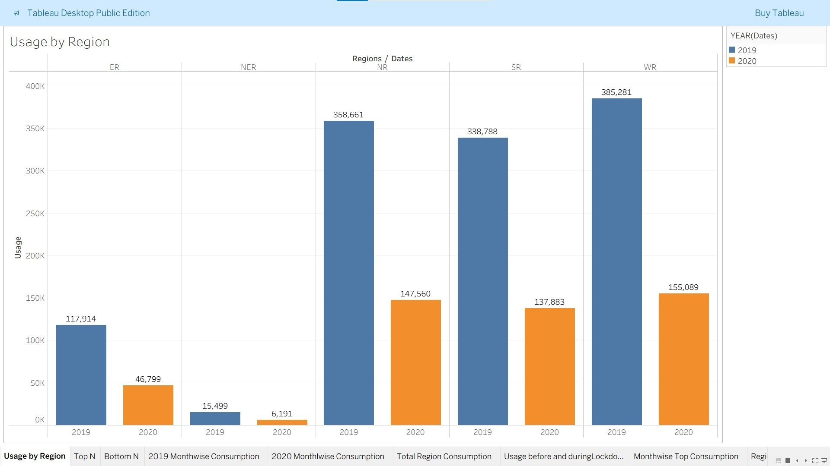
Figure 1: Regional Electricity Usage Comparison (2019 vs 2020)
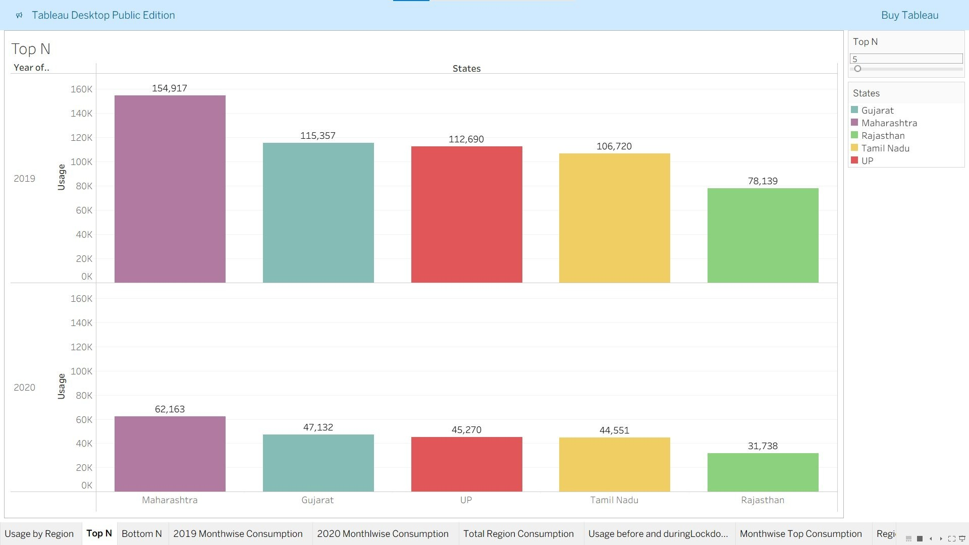
Figure 2: Top N States Consumption Analysis
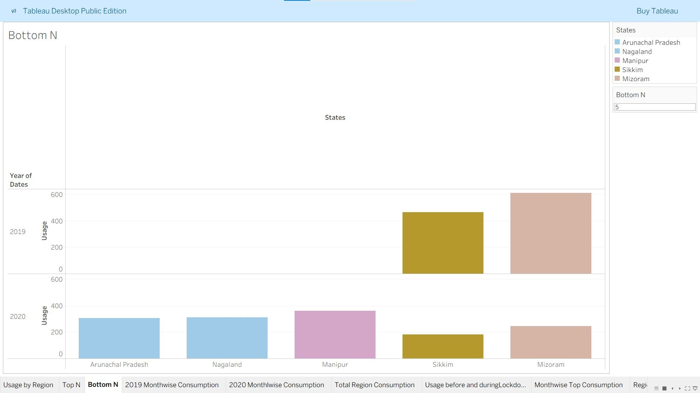
Figure 3: Bottom N States Consumption Analysis
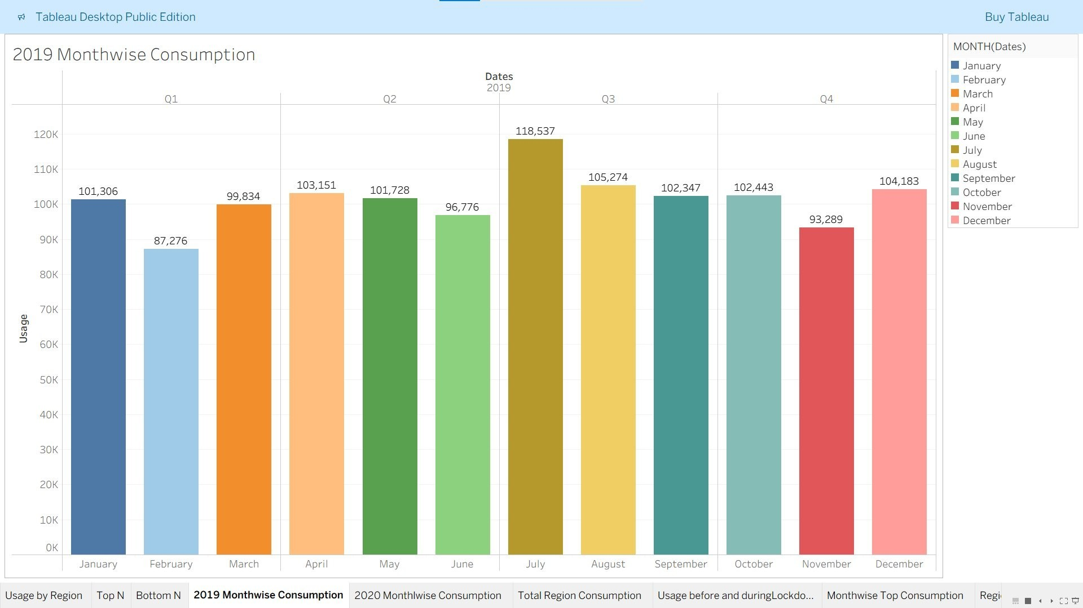
Figure 4: 2019 Monthwise Consumption Trends
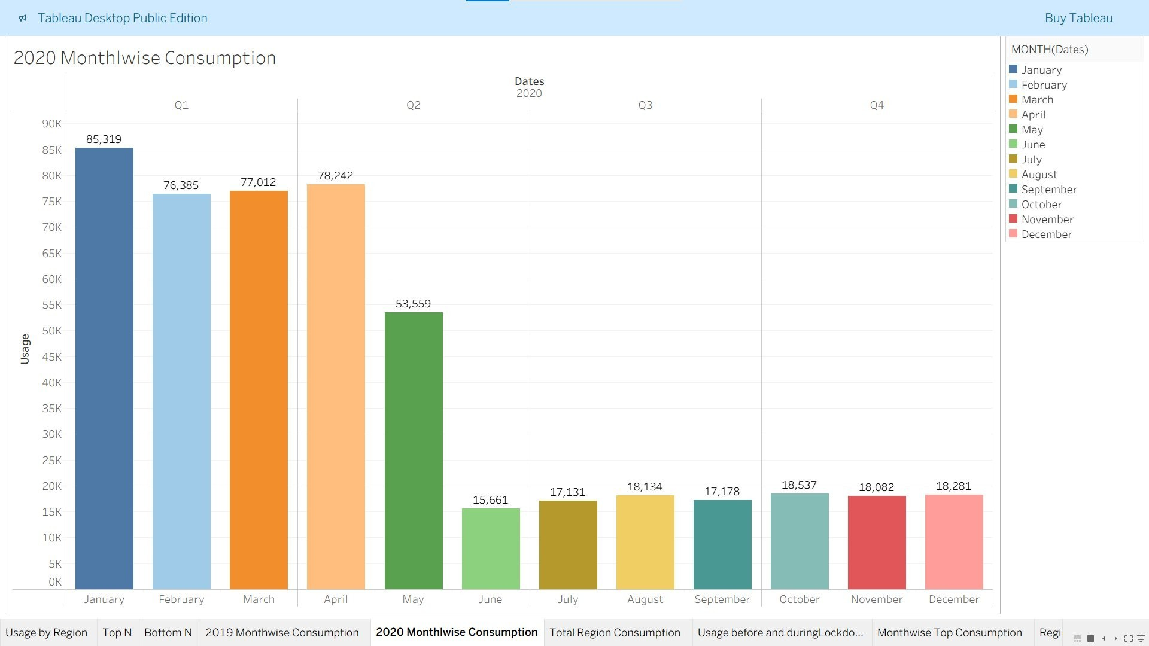
Figure 5: 2020 Monthwise Consumption Trends
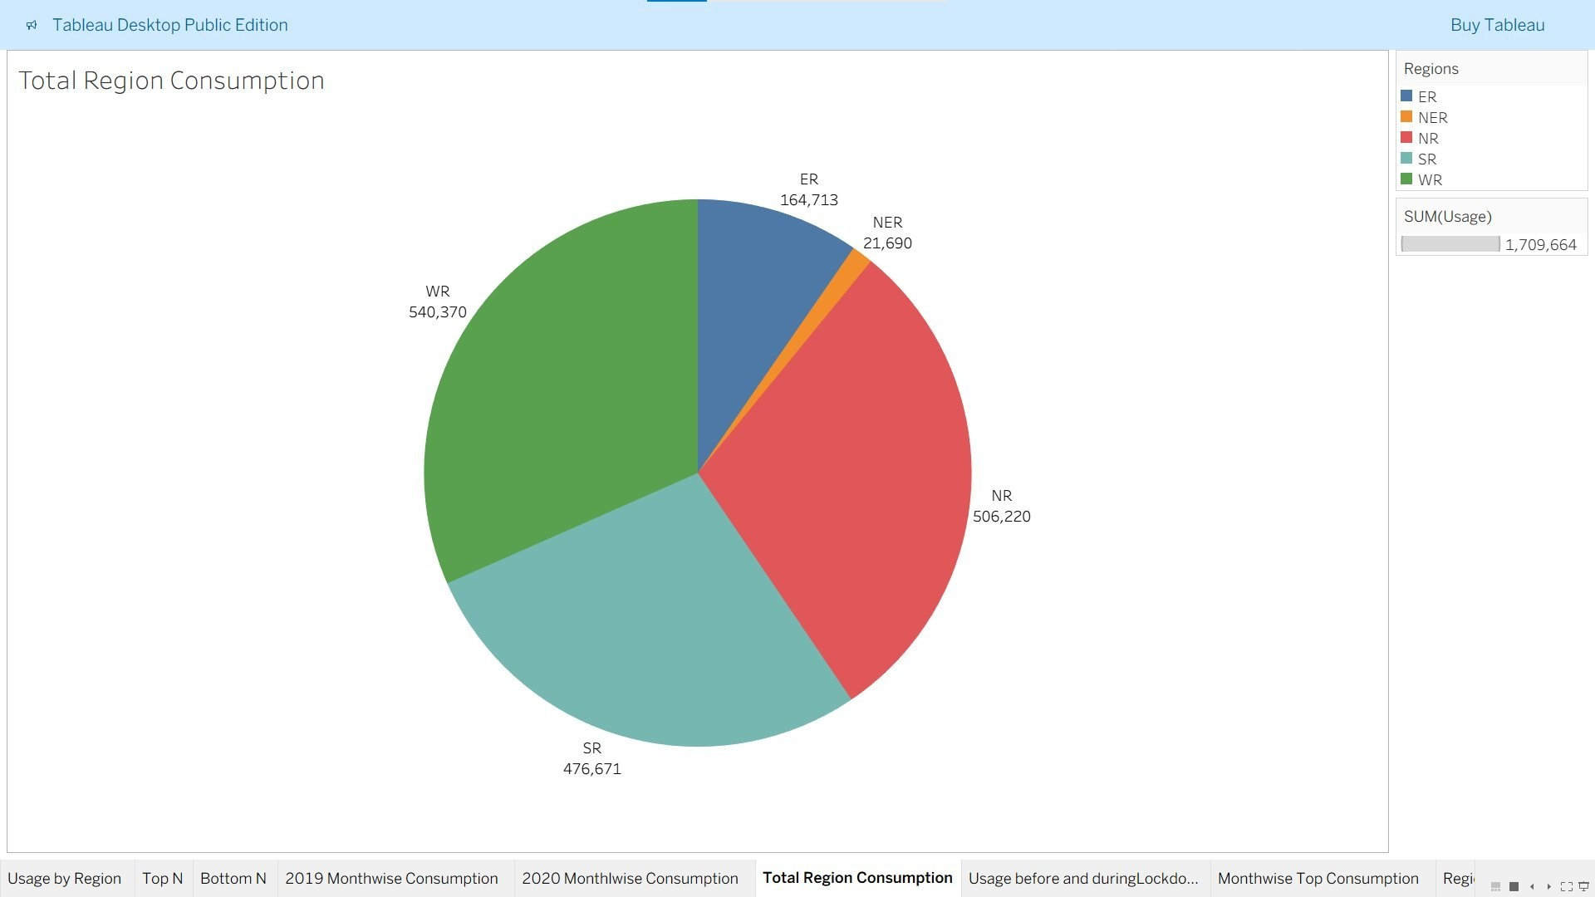
Figure 6: Total Region Consumption Distribution
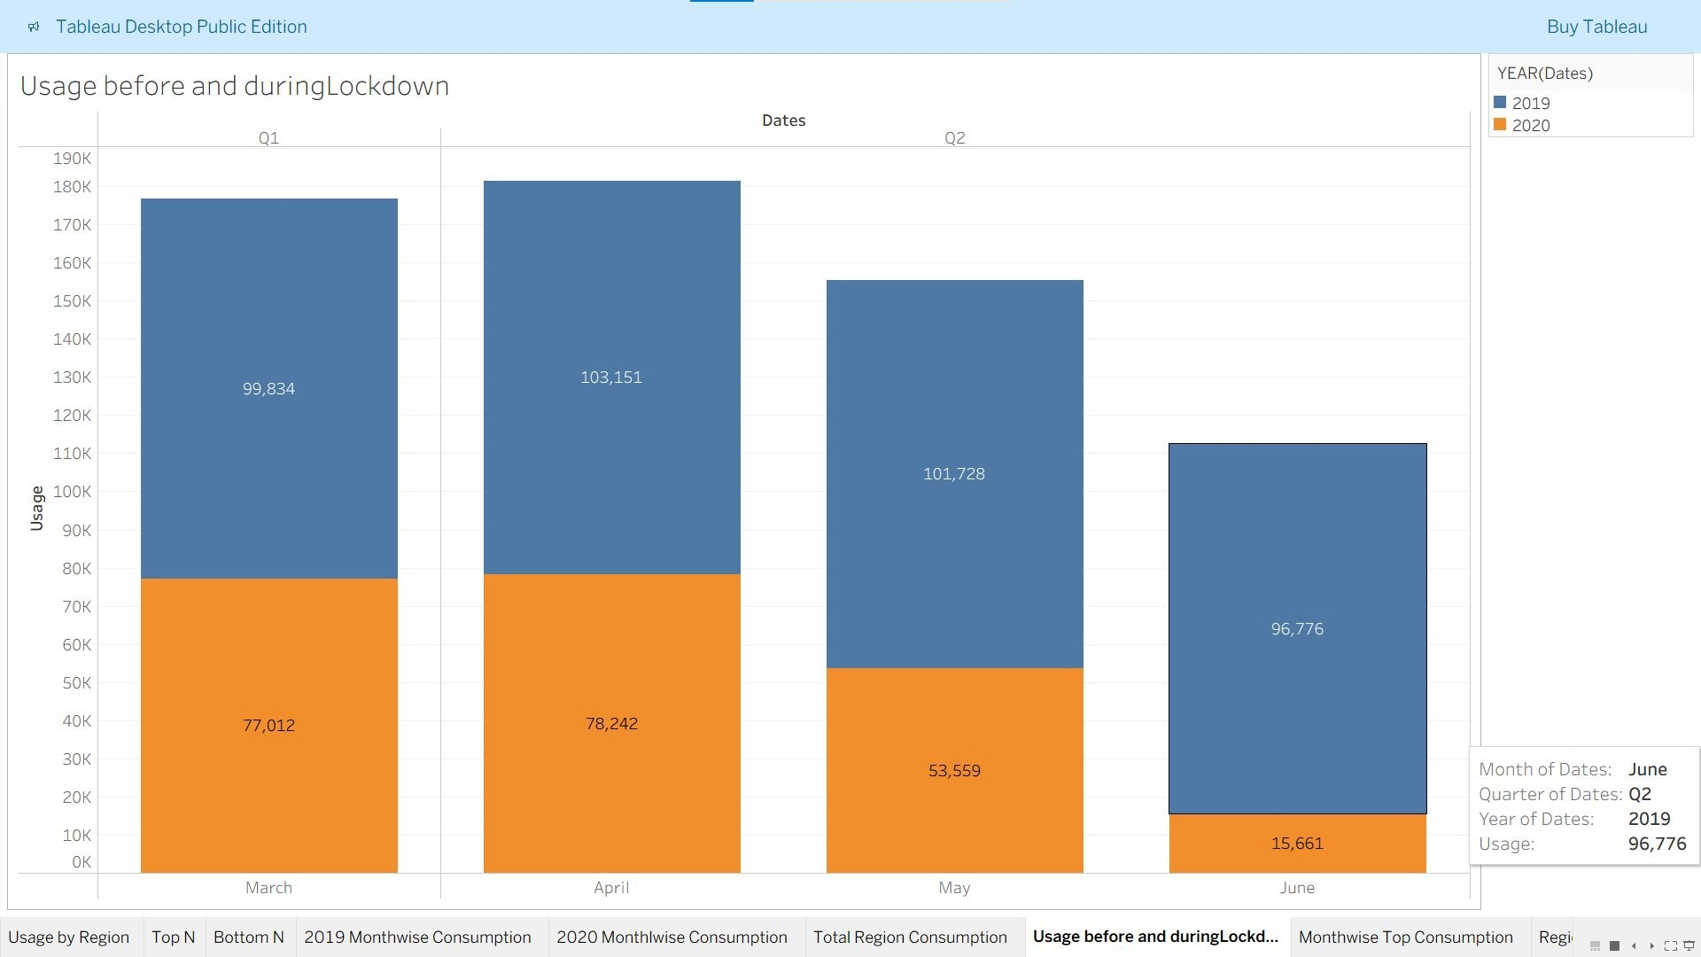
Figure 7: Consumption Before and During Lockdown
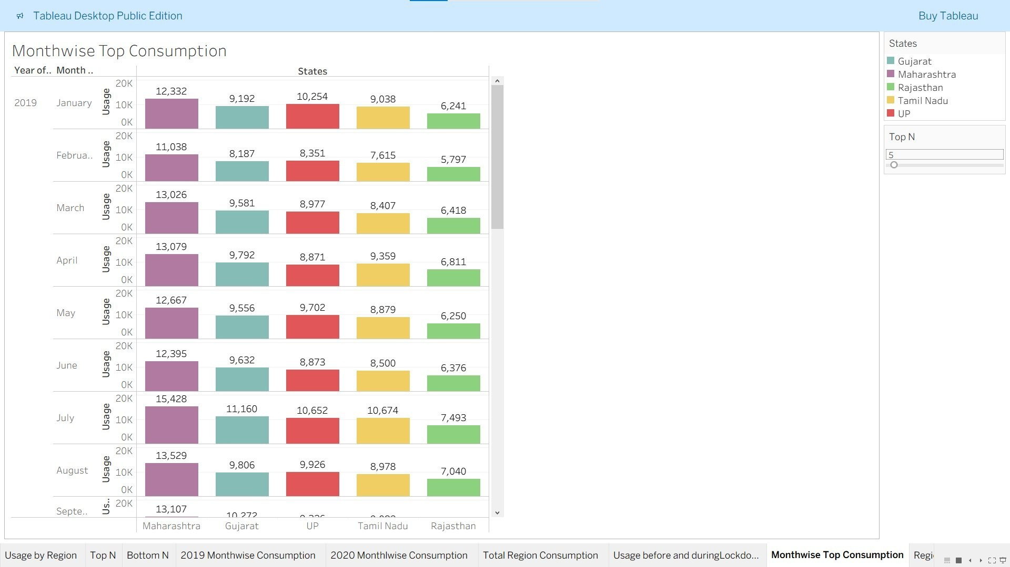
Figure 8: Monthwise Top Consumption Analysis
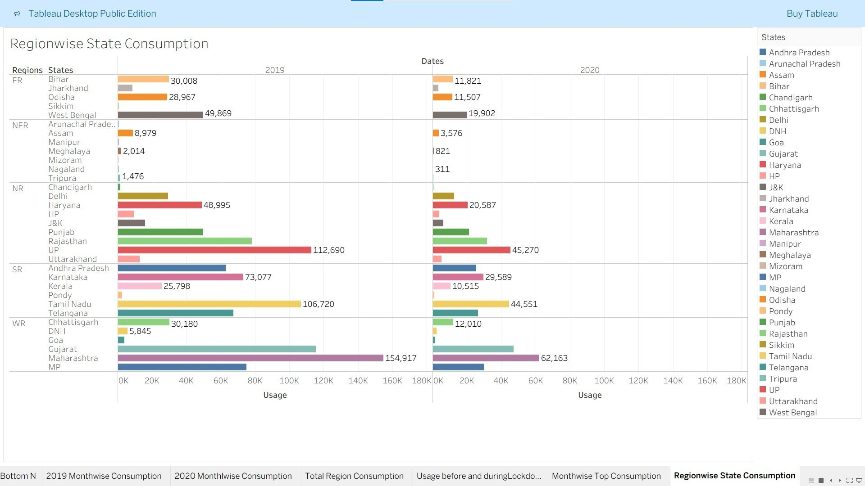
Figure 9: Regionwise State Consumption Analysis
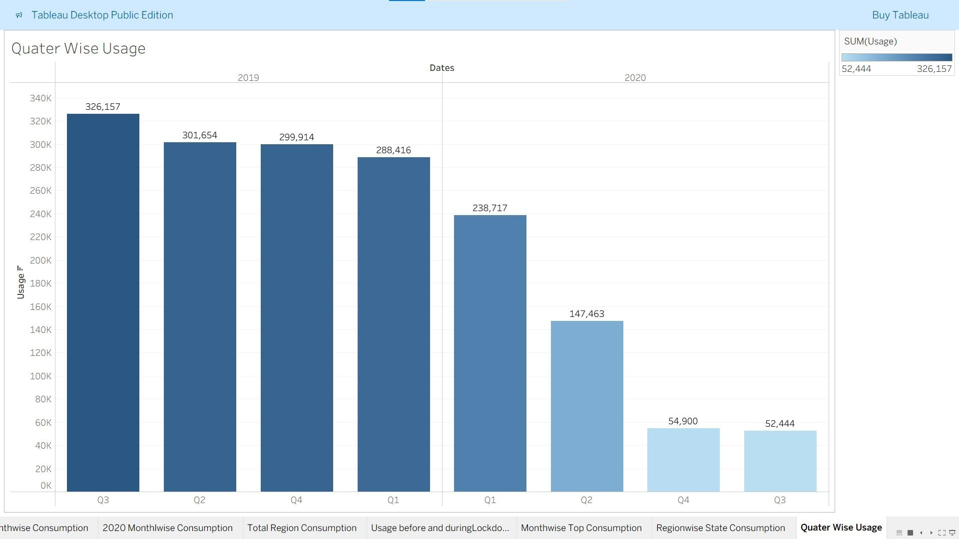
Figure 10: Quarter Wise Usage Analysis
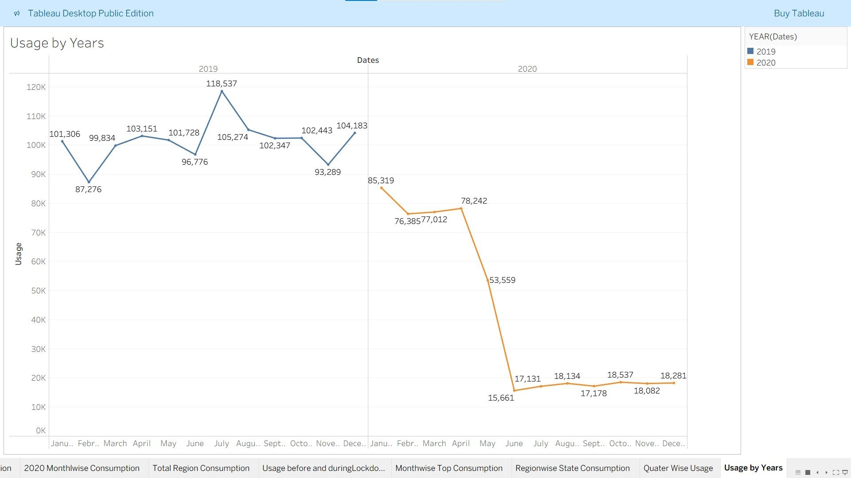
Figure 11: Usage by Years Comparison
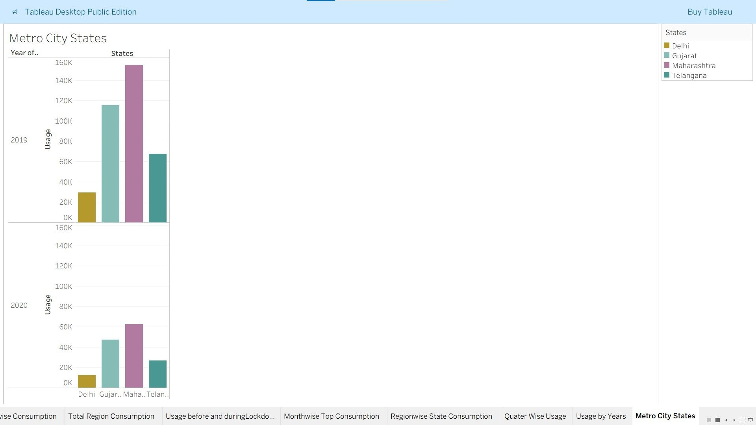
Figure 12: Metro City States Consumption
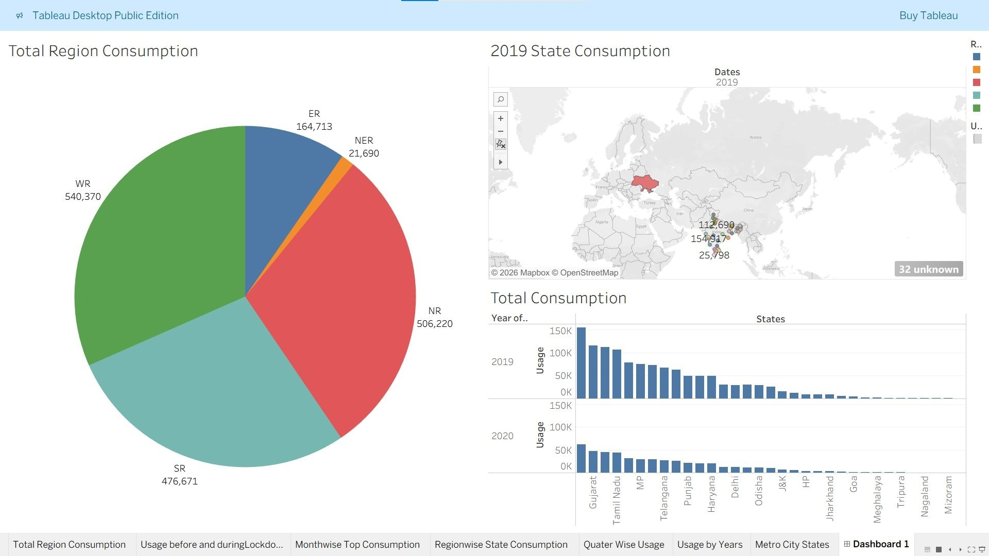
Figure 13: Regional and State Consumption Dashboard
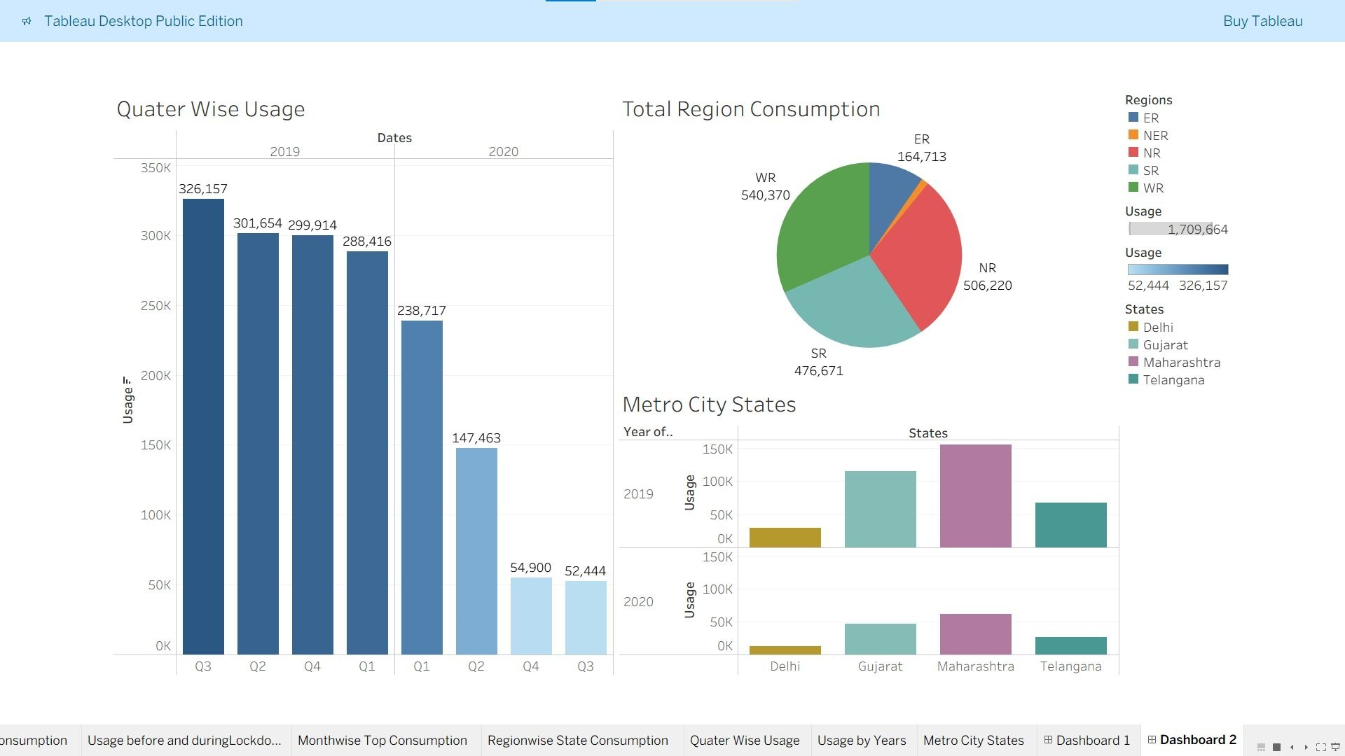
Figure 14: Comprehensive Dashboard View
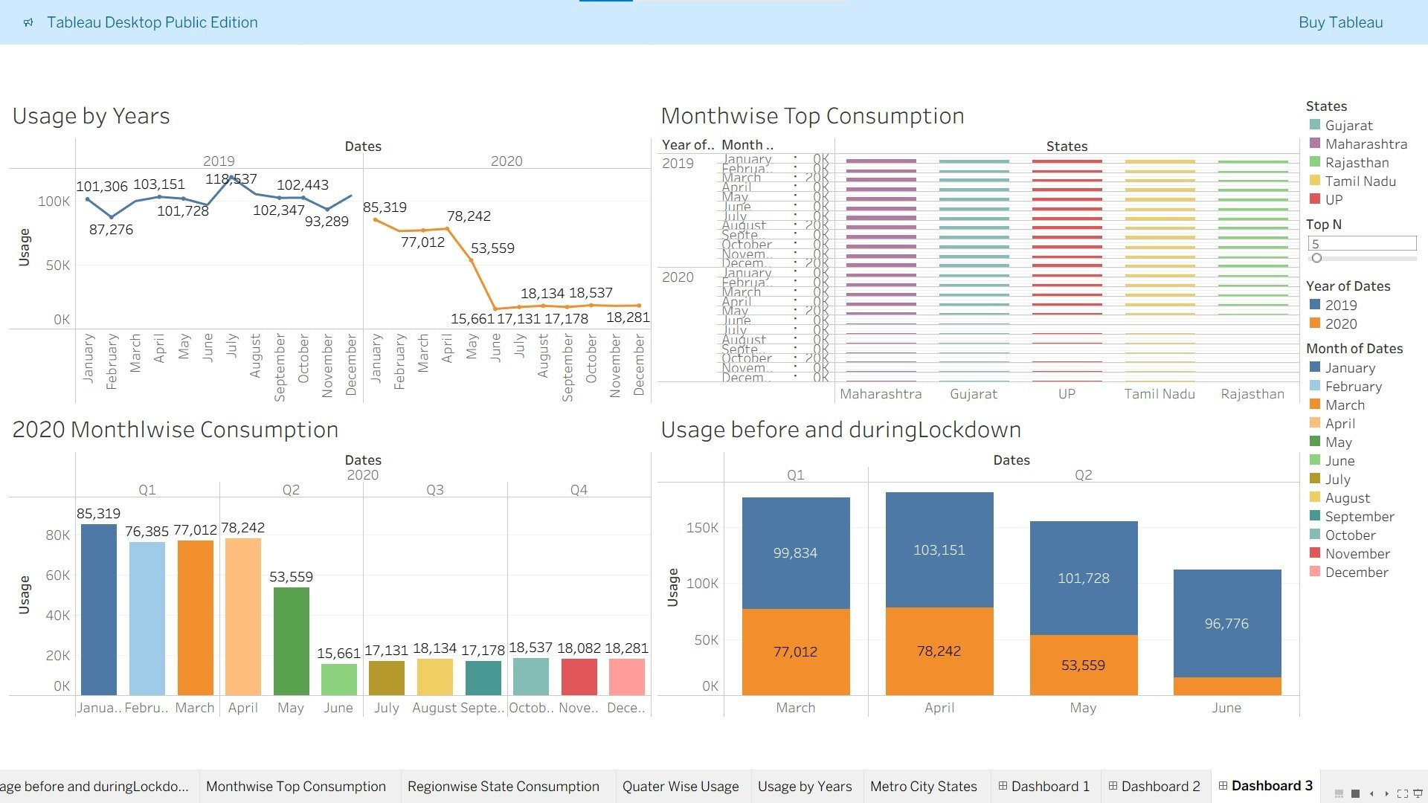
Figure 15: Multi-dimensional Analysis Dashboard
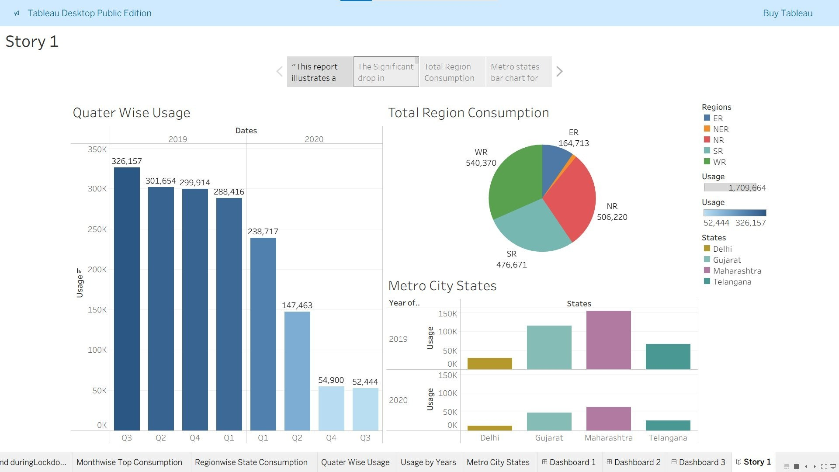
Figure 16: Story 1 - Key Insights Visualization
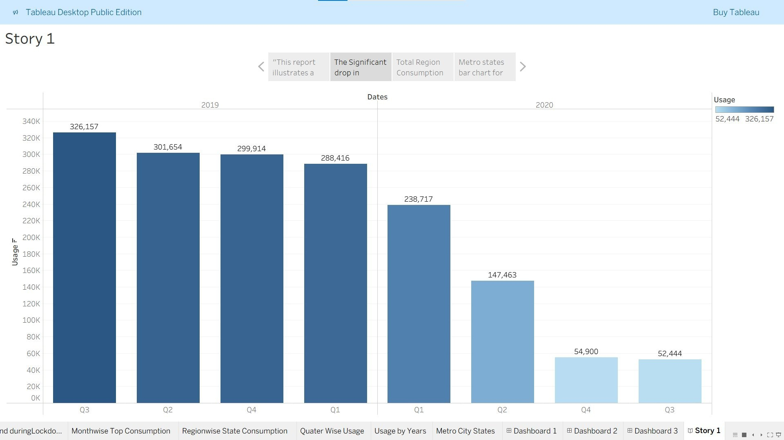
Figure 17: Story 1 - Quarter Wise Analysis
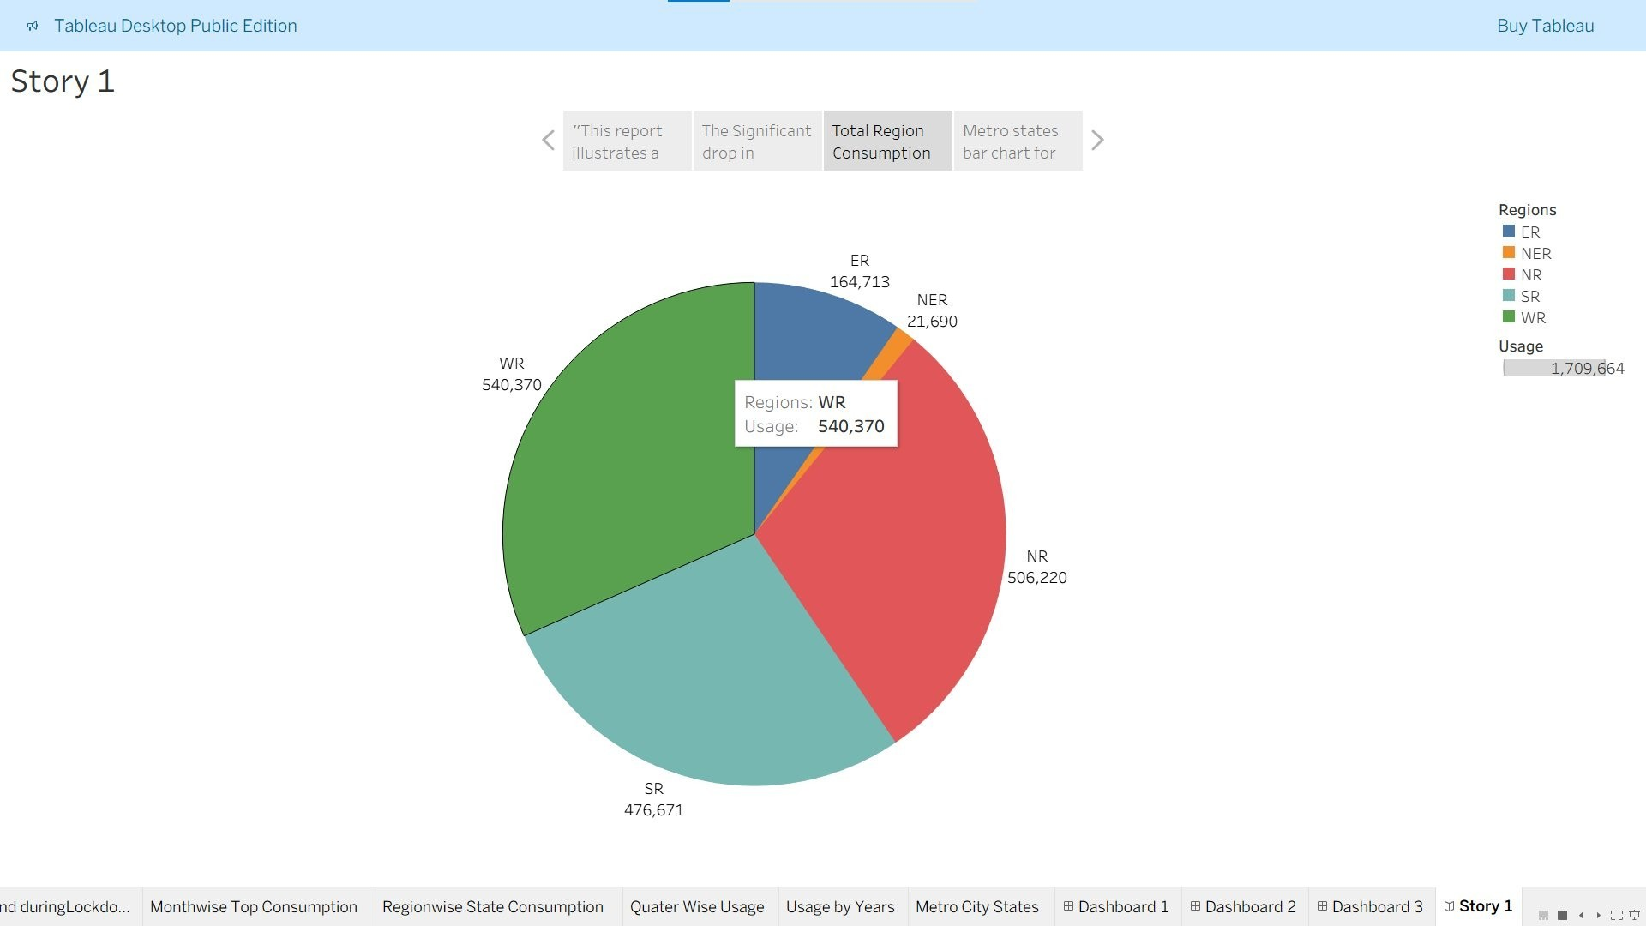
Figure 18: Story 1 - Regional Distribution
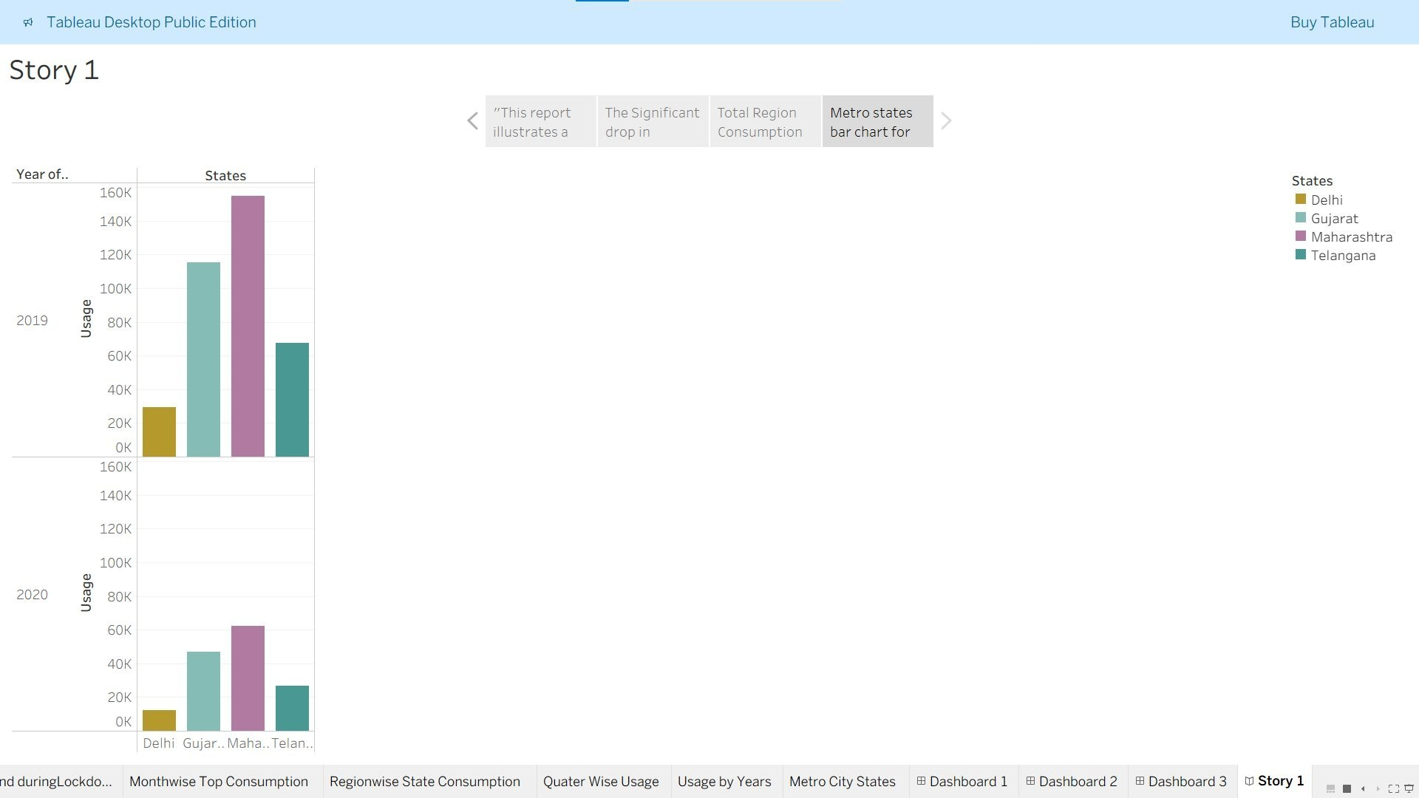
Figure 19: Story 1 - Metro City States Analysis

7.2 Key Findings
Scenario 1 - Overall Consumption Trends:
- National electricity consumption showed typical seasonal patterns in 2019 with peaks during summer and winter months
- March-June 2020 lockdown period resulted in notable reduction in electricity demand across most sectors
- Peak decline observed in April-May 2020 coinciding with strictest lockdown measures
- Industrial and commercial consumption dropped significantly while residential consumption increased
- Recovery began from July 2020 onwards with gradual return to normal consumption patterns
Scenario 2 - Regional Variations:
- Southern states maintained relatively stable consumption despite lockdown, indicating resilient industrial base
- Northern states experienced sharper fluctuations, particularly in agricultural sector dependent areas
- Western states showed faster recovery trajectory post-lockdown
- Northeastern states demonstrated lower absolute consumption but consistent regional demand patterns
- Eastern states showed varied patterns with some states recovering quickly while others lagged
Scenario 3 - Recovery Analysis:
- By September 2020, most states had recovered 80-90% of pre-lockdown consumption levels
- By December 2020, majority of states exceeded pre-lockdown consumption baseline
- Recovery was faster in states with higher industrial concentration
- Agricultural-dependent states showed steadier but slower recovery patterns
- Regional economic characteristics strongly influenced recovery speed
Statistical Summary
Period | Avg Consumption (GWh) | Peak Consumption (GWh) | Consumption Change (%)
Jan-Feb 2020 (PreLockdown) | ~85,000 | ~104,000 | Baseline
Mar-Jun 2020 (Lockdown) | ~61,000 | ~78,000 | -28.2%
Jul-Dec 2020 (Recovery) | ~68,000 | ~93,000 | -20.0%
Full Year 2020 vs 2019 | ~65,000 | ~104,000 | -16.5%

8. ADVANTAGES & DISADVANTAGES
Advantages of the Analysis Approach:
- Comprehensive Coverage: Includes all Indian states across 24-month period
- Multi-dimensional Analysis: Considers national, regional, and sectoral perspectives
- Temporal Precision: Month-by-month granularity captures precise impact timing
- Real-world Relevance: Addresses critical pandemic-related questions
- Statistical Rigor: Employs validated analytical techniques
- Actionable Insights: Findings directly applicable to policy and planning
- Scenario-based Framework: Organized approach facilitating easy interpretation
- Interactive Visualizations: Tableau enables dynamic exploration of data✓ Reproducibility: Methodology can be applied to other time periods or regions Limitations and Disadvantages:
- Data Granularity: Monthly data may obscure week-to-week variations
- Sectoral Attribution: Cannot precisely attribute consumption to specific sectors without detailed consumption data
- External Factors: Other variables (weather, policy, tariff changes) not fully captured✗ Forecasting Uncertainty: Post-lockdown period still showing adjustment, affecting trend establishment
- Regional Heterogeneity: High variation within regions limits generalization
- Data Quality: Potential reporting inconsistencies across states
- Time Lag: Some state reporting may have processing delays
- Limited Predictive Power: 2020 data may be anomalous, complicating future forecasting

9. CONCLUSION
This comprehensive analysis of Indian electricity consumption patterns from January 2019 to December 2020 provides critical insights into how the COVID-19 pandemic affected energy demand across the nation.
Key Conclusions:
- Pandemic Impact Magnitude: The nationwide lockdown resulted in a measurable but temporary reduction in electricity demand, with the most significant impact during April-May 2020 (approximately 28% decline).
- Regional Resilience: Different regions demonstrated varying capacity to maintain consumption levels during disruption, with industrial and service-sector-dependent states showing greater vulnerability than those with diversified economies.
- Rapid Recovery: Despite initial sharp decline, the Indian electricity sector demonstrated remarkable resilience, with most regions recovering to near pre-lockdown levels by late 2020, indicating underlying economic strength.
- Sectoral Shifts: The pandemic induced structural shifts in consumption patterns, with increased residential usage offsetting significant industrial and commercial declines.
- Policy Implications: The analysis reveals the critical importance of regional diversity in infrastructure planning and the need for flexible, adaptive energy management strategies.
- Growth Potential: The analysis affirms India's continued potential for electricity consumption growth as economic activity normalizes and development continues.
This analysis demonstrates the value of electricity consumption data as a real-time indicator of economic health and activity levels, making it essential for policy makers, planners, and utility operators.

10. FUTURE SCOPE
Potential Extensions and Future Work:
1. Sectoral Decomposition:
- Obtain detailed sector-wise consumption data (agriculture, industry, residential, commercial)
- Conduct sector-specific impact analysis • Identify sector-specific recovery trajectories
2. Granular Temporal Analysis:
- Incorporate weekly or daily consumption data for better trend identification
- Analyze hourly patterns during lockdown and recovery periods • Identify specific dates of policy changes and their immediate impacts
3. Causal Analysis:
- Integrate economic indicators (GDP, employment, industrial production)
- Weather and climate data correlation analysis
- Policy intervention impact assessment
4. Predictive Modeling:
- Develop ARIMA/Prophet models for short-term forecasting
- Machine learning models for consumption prediction
- Scenario-based forecasting for policy planning
5. Comparative Analysis:
- Compare India with other countries' pandemic energy impacts
- Cross-country recovery pattern analysis • Learning from international best practices
6. Sustainability Assessment:
- Analyze renewable energy integration patterns
- Carbon footprint implications of consumption patterns
- Clean energy transition tracking
7. Advanced Visualization:
- Interactive dashboards for real-time monitoring
- Animated visualizations showing temporal evolution
- 3D visualization of regional variations
8. Policy Scenario Modeling:
- Simulate impact of different policy interventions
- Forecast consumption under various development scenarios
- Infrastructure planning support models

11. APPENDIX 11.1 Data Sources
Primary Data Source:
- State-wise electricity consumption data from Ministry of Power, Government of India
- Time period: January 2019 - December 2020
- Granularity: Monthly state-level aggregated data
- Geographic Coverage: All Indian states and Union Territories
Data Quality:
- Verified and published by central government agencies
- Reconciled with power distribution company reports
- Quality-checked for consistency and completeness

11.2 Methodology Reference
Statistical Methods Employed:
1. Time Series Analysis:
- Trend analysis using moving averages
- Seasonal decomposition (STL decomposition)
- Year-over-year comparisons
2. Comparative Analysis:
- Regional aggregation and comparison
- Mean, median, and standard deviation calculations
- Percentage change analysis
3. Recovery Assessment:
- Pre-lockdown baseline establishment
- Recovery rate calculation
- Time-to-recovery metrics
4. Visualization Techniques:
- Line plots for temporal trends
- Bar charts for regional comparisons
- Heatmaps for monthly patterns
- Box plots for distribution analysis

11.3 Definitions and Acronyms
Term | Definition
COVID-19 Lockdown | Nationwide restrictions imposed from March 25,
 | 2020 to June 7, 2020
Pre-lockdown Period | January 1, 2019 - March 24, 2020
Lockdown Period | March 25, 2020 - June 7, 2020
Recovery Period | June 8, 2020 - December 31, 2020
Consumption | Total electricity supplied to consumers (measured in GWh)
Regional States | States grouped by geographic location: North, South, East, West, Northeast
Year-on-Year | Comparison of same period in consecutive years
GWh | Gigawatt-hour - unit of electrical energy (1 GWh = 1 million kWh)

11.4 References
- Ministry of Power, Government of India. "State-wise Electricity Consumption Reports." Retrieved from power ministry official portal.
- Central Electricity Authority (CEA). "Monthly Performance Reports - 2019, 2020." Government of India publications.
- World Bank. "World Development Indicators - India Energy Statistics." Available at: worldbank.org/indicator
- Indian Bureau of Mines. "Mineral Production Statistics." Government of India publications.
- COVID-19 Timeline and Policy Information.
Retrieved from Ministry of Home Affairs, Government of India.

11.5 Project Demo & Resources
Project Demo Link:
https://drive.google.com/file/d/14t92-EwTTxqIYLq8KH00PWjbiGMtl_at/view?usp=drivesdk
This link contains:
- Interactive Tableau Dashboard with multiple story views
- Detailed visualizations of all three scenarios
- State-wise and regional consumption breakdowns
- Month-by-month consumption trends
- Recovery trajectory analysis
- Comparative metrics and KPIs
The dashboard is built using Tableau Desktop Public Edition and includes:
- Multiple interconnected visualizations
- Interactive filters for region, state, and time period selection
- Drill-down capabilities for detailed analysis
- Story-based narrative for key insights• Export capabilities for further analysis
Access Instructions:
- Click the link above
- The dashboard will open in your default browser
- Use filters to explore specific regions or states
- Hover over charts for detailed tooltips
- Click on regions in pie charts to filter other visualizations

